

Library Management System

A Guide to the project

| Data Structures and Algorithms | 2022-09-04

# Intro

This Guide is to help explain a few components of the code for the DSA Presentation on Tuesday. Please note that the lecturer will randomly choose who to present and answer the following questions.

## Structure of guide

This guide is very simple. It’s going to entail a few in-depth explanations of functions or code that are somewhat confusing.

The document would contain pictures of code snippets and their explanations.

The whole project can be found in this [GitHub repository](https://github.com/pappykojo/Library-management-system).

Functions

# def check_files_exist():

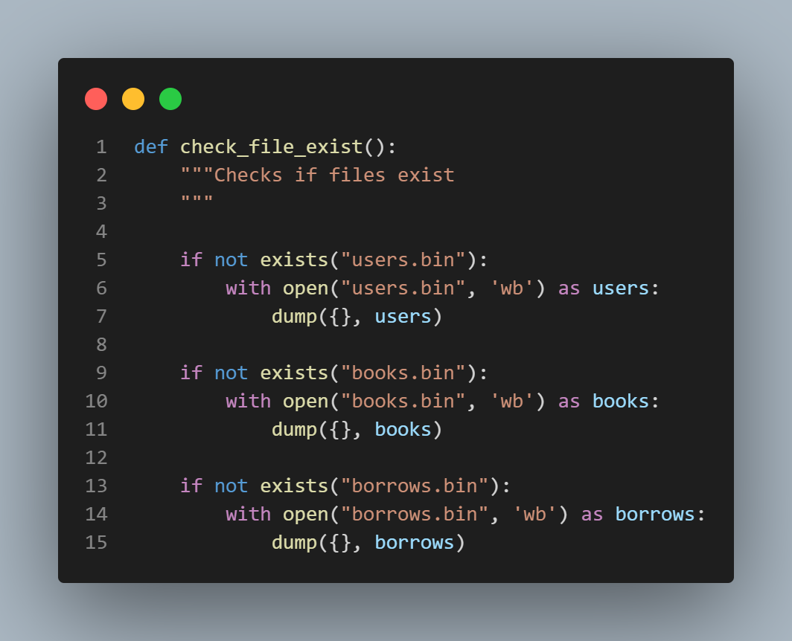

This code is to check if the necessary files needed for the program to function correctly, exist in the folder it’s in.

As the code implies, if it doesn’t exist, then the “with open()” function creates the file as a “write-binary (wb)” file.

The dump() method is used when the Python objects have to be stored in a file.

# def add_user():

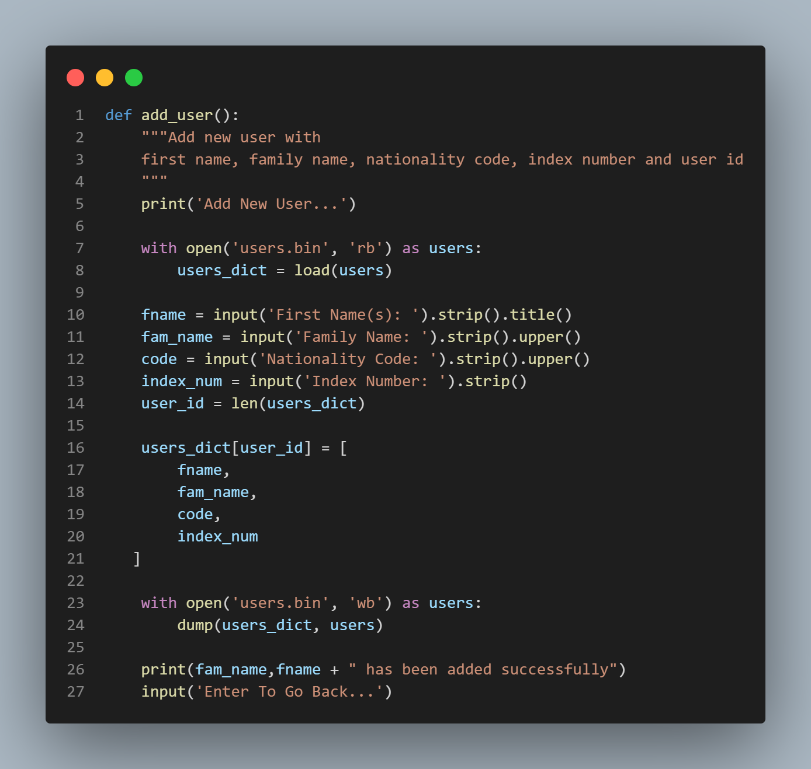

This function is used to add a new user to the library.

From line 7, the code opens up the users.bin file in the folder and labels it as ‘users’. Now it places the file (users), in a variable (users_dict) using the load() method.

From lines 10 to 14, the program prompts the user to input the details of the new user to be added into the file ‘users.

The user_id variable takes the length of the users.bin file and assigns it to the index of the new user making it the user ID of the new user.

The users_dict variable is updated using the user_id to list the information got from the prompts.

Lines 23 and 24 put everything back into the users.bin file.

Line 26 prints out a message that confirms everything has been successful.

# def add_book():

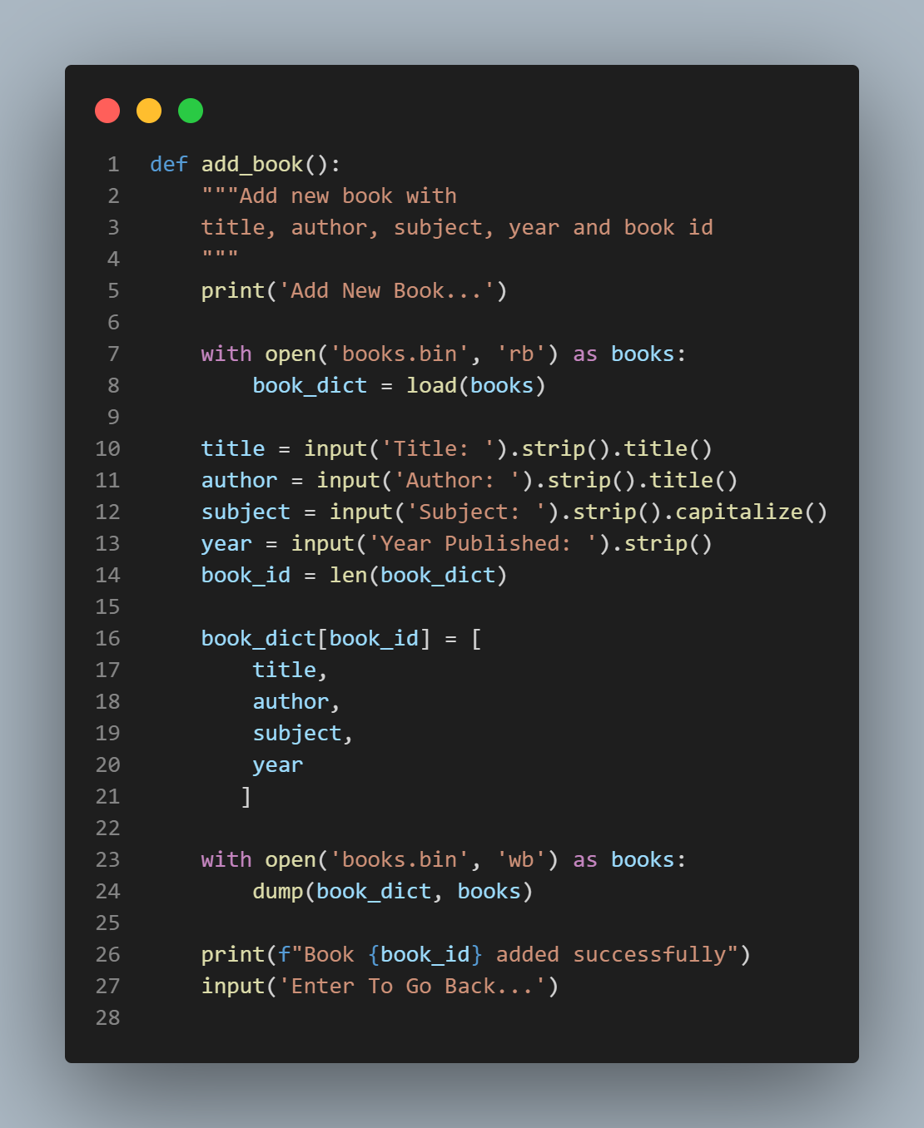

This code does the same things as that of the previous function.

# def search_book():

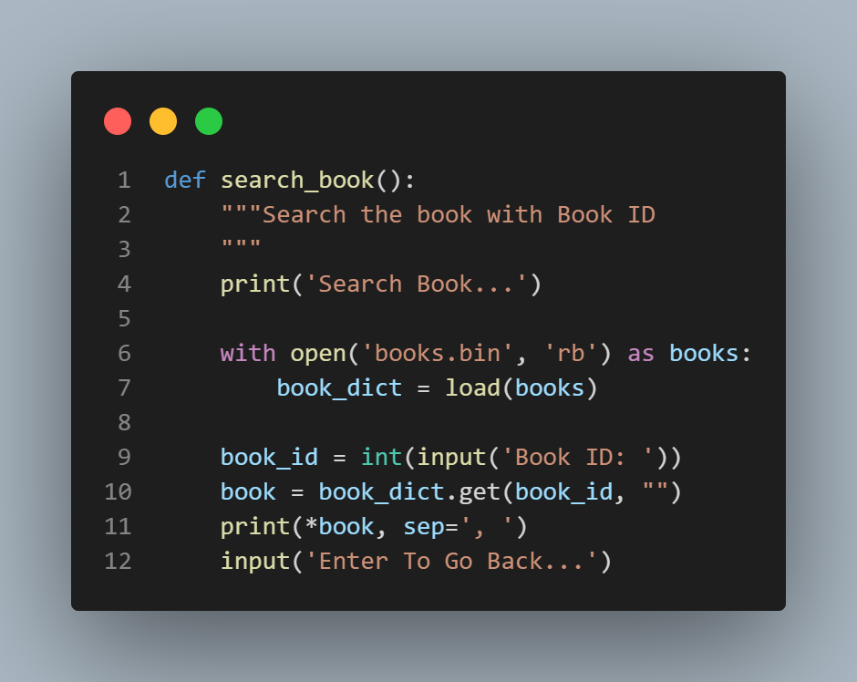

Line 9 asks the user for the ID of the book to be searched. Line 10 declares a variable “book” which stores the information of the book found in the book_dict (which is also the file “books.bin”)

Line 11 prints the information in the book variable separating every section with a “,” as indicated by the “sep” method.

# def borrow():

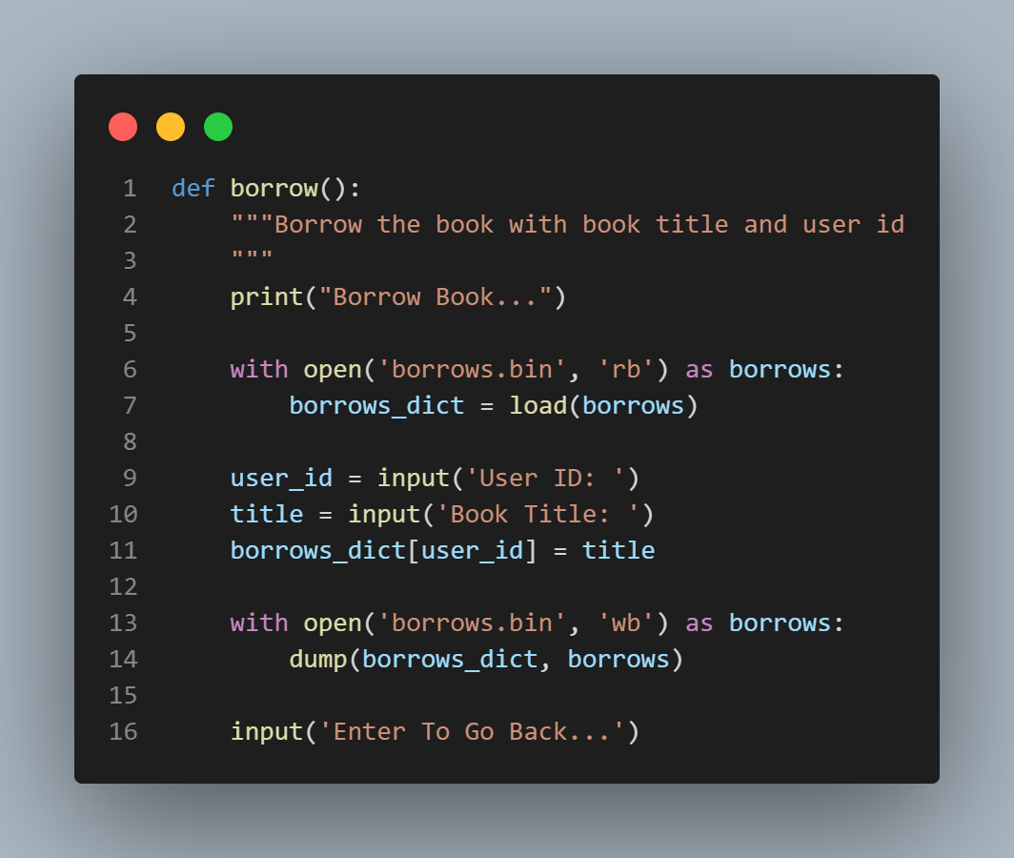

Line 9 and 10 asks for the user’s ID and the title of the book to be borrowed respectively and saves them in the variable borrows_dict. This gets dumped in the borrows.bin file

# def show_all_info()

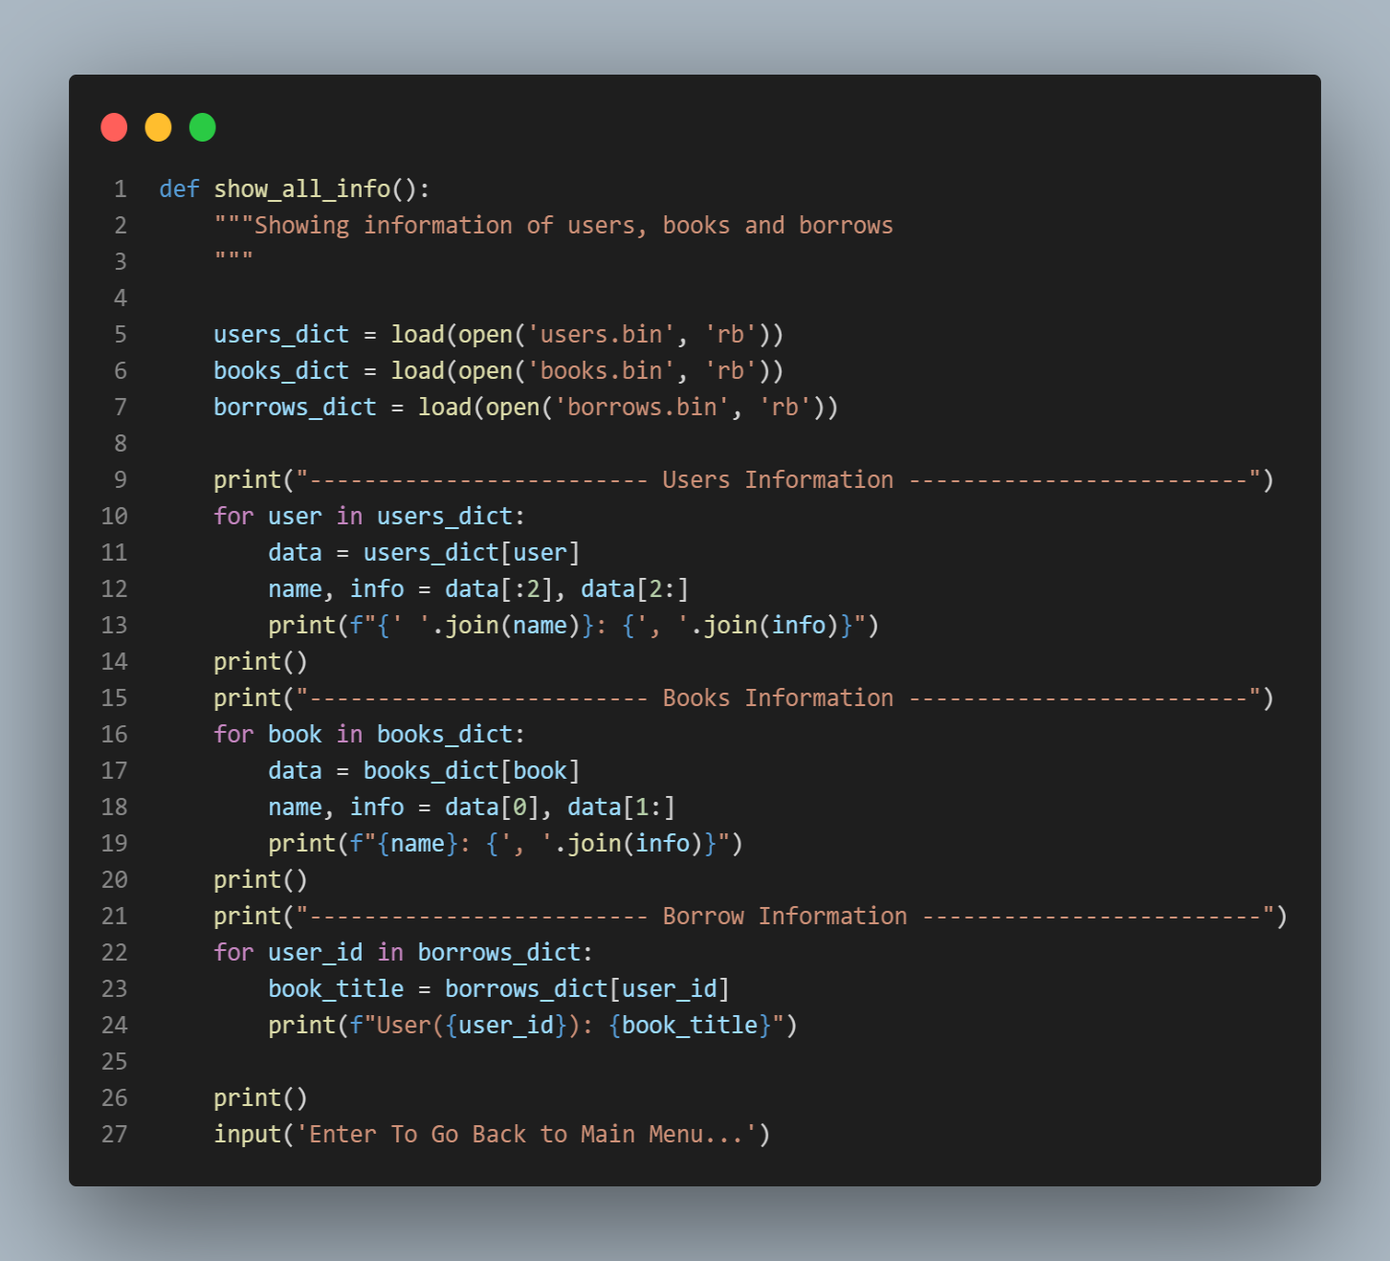

Lines 5 to 7 has codes to open the saved files that has everything the program has ever saved.

Lines 10 to 13 are for loops that print every user and his or her information unto the screen. The same thing happens in lines 16 to 18 and 22 to 23.

Line 12 and 18 are variables that store the name and information separately and print them out using the range method ([:2])

Lines 13 and 19 have a “.join” method, it is used to concatenate any number of strings. The string with the method is inserted in between each given string, resulting in a new string.